**Lab 03_K-Map Simplification**

***General Statement:*** Implement function **F(A,B,C,D) = Sum(0,1,7,13,15) +Don’t Cares(2,6,8,9,10)** by onlyusing the **EDAPlayground**.

Your completed report should include:

1. This cover sheet, followed by
2. Function table (truth table) for the above function (pictures of hand drawing are acceptable)

**(3)** K-map simplification showing detailed derivations (pictures of hand drawing are acceptable)

**(4)** A printout of the both Verilog codes, followed by

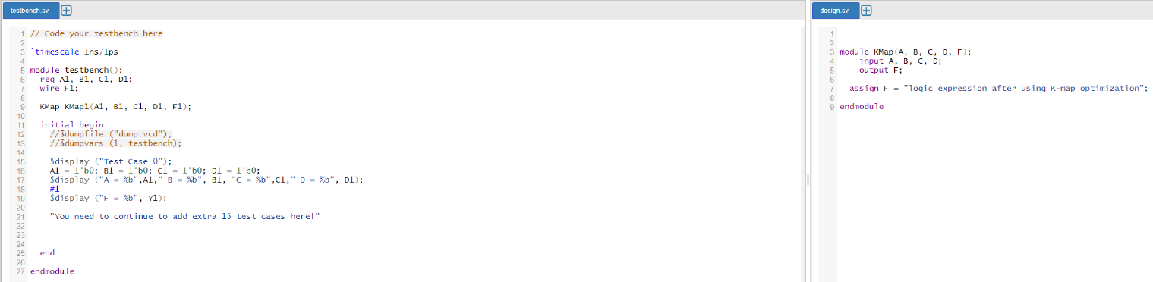 **(5)** A printout of the timing diagram showing the output with respect to sixteen input combinations and clearly matching the function table